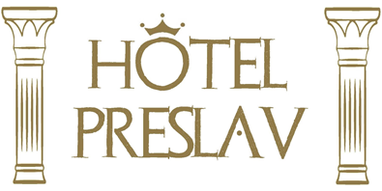

ALL INCLUSIVE
SUMMER SEASON 2024

Meals:
Breakfast (07.30 - 10.00) – on buffet: milk products, sausages, eggs, pastry, cereals, fruits, vegetables, chocolate, jams, beverages (coffee, tea, water, non-alcoholic beverages from a post-mixer).
Lunch (12.00 - 14.00) – on buffet: salads, warm and cold soup, meat and meatless main dishes, warm and cold side dishes, seasonal fruits and vegetables, dressing, spaghetti or other pasta, desserts and creams, beverages.
Afternoon snack (16:00 – 17:00) – on buffet: snacks, pretzels, pizza, fruits, ice-cream, tea and coffee.
Dinner (18:30 – 21:00) – on buffet: salads, warm and cold soup, meat and meatless main dishes, warm and cold side dishes, seasonal fruits and vegetables, dressing, spaghetti or other pasta, desserts and creams, beverages.
Beverages:
- Lobby bar:
- from 07:30 till 21:00 - water, coffee, tea, non-alcoholic beverages from a post-mixer (Coca cola, Cola Light, Sprite, Fanta Orange, Tonic, Soda water), soar cherry juice and orange juice.
- from 10:00 till 21:00 - local alcohol (brandy, gin, vodka, rum, mint, mastic), local wine and beer.
- Restaurant bar - water, non-alcoholic beverages from a post-mixer (Coca cola, Cola Light, Sprite, Fanta Orange, Tonic, Soda water), soar cherry juice and orange juice; local alcohol (brandy, gin, vodka, rum, mint, mastic), local wine and beer are served during the lunch and the dinner.

The hotel also offers: sunbeds and sun umbrellas at the swimming pool, free of charge Wi-Fi internet access in the common areas.

